Embryonic stem cells could help restore sight to blind
Photoreceptors grown from embryonic stem cells have been successfully implanted in the retinas of blind mice
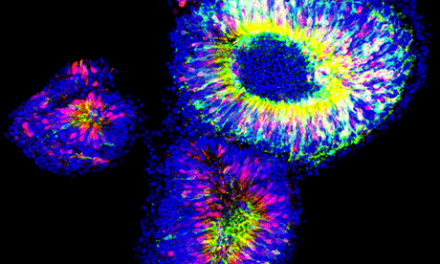
Nascent retinas grown from embryonic stem cells. Photoreceptors were isolated from them and transplanted into mice. Photograph: Anai Gonzalez-Cordero

Scientists have shown that light-sensitive retinal cells, grown in the lab from stem cells, can successfully integrate into the eye when implanted into blind mice. The technique opens up the possibility that a similar treatment could help people who have become blind through damage to their retinas to regain some of their sight.
Loss of light-sensitive nerve cells, known as photoreceptors, is a major cause of blindness in conditions such as age-related macular degeneration, retinitis pigmentosa and diabetes-related blindness. These conditions affect many thousands of people in the UK alone and there is no effective treatment at present. Scientists have been exploring the possibility of somehow replacing the photoreceptors, which come in two types: rods that help us see in low light conditions, and cones, which help us differentiate colours.
Robin Ali at University College London's Institute of Ophthalmology and Moorfields Eye Hospital has previously shown that transplanting immature rod cells from the retinas of very young mice can restore vision in blind adult mice. It was a neat proof of concept, but the technique as it stood would be impractical as a way to treat people.
His latest work got around the problems of sourcing donor photoreceptor cells by growing and differentiating them from embryonic stem cells in a culture dish, rather than taking the cells from young mice. The donor photoreceptors developed normally once inside the adult mouse eyes and, crucially, formed nerve connections with the brain. The results arepublished on Sunday in the journal Nature Biotechnology.
It will be at least five years before the technique is ready for human trials, said Ali, but he is confident that this will happen. "Now that we have proved the proof-of-concept, the road is clear to the first set of clinical trials just to see whether it'll work," he said. "It certainly isn't a case of rolling out treatments in five years' time and providing therapies. It's taken us 10 years to get here and it'll take us five years to get started in people."
Over the past decade, Ali's team has made the process of transplanting photoreceptors into the eyes of mice more and more efficient. In 2006, when they transplanted 200,000 cells, only 1,000 cells successfully integrated into the retina of the mouse. Now that success rate is up to around 40,000 cells.
"If we can transplant 20,000 cones in [a person with] macular degeneration, I think there's potential for tremendous clinical benefit because humans don't need very many functioning cones for a really useful function," said Ali. "The foveola, in the centre of the fovea [in the retina], which is responsible for really high visual acuity – things like reading – has only 20,000 cones. That gives you an idea just how few cells you might need."
Professor Chris Mason, a stem cell biologist at University College London, said the big challenge for Prof Ali's work would be whether it worked in patients. "Restoring the sight for the 'three blind mice' may be far easier than for the 'farmer's wife'. Before human clinical trials can commence, the mouse model will require significant optimisation, for example increasing the efficiency of new photoreceptors to connect with the damaged retina. However, there is no doubt that this breakthrough, either directly as the basis of a future cell therapy, or indirectly by expanding our knowledge, will significantly contribute to the fight against blindness."
Dr Dusko Ilic, a stem cell scientist at King's College London, said that the work was an important step but that it was only a small step on a long road to clinical trials and eventually therapeutic use in humans. "We should not get over-enthusiastic."

